**SIT 315 (Programming Paradigms)**

**TASK – M3_S2P**

Name – Akshay Kumar

Id - 2210994757

**Activity 1**

**Ans1)** The below is the master code

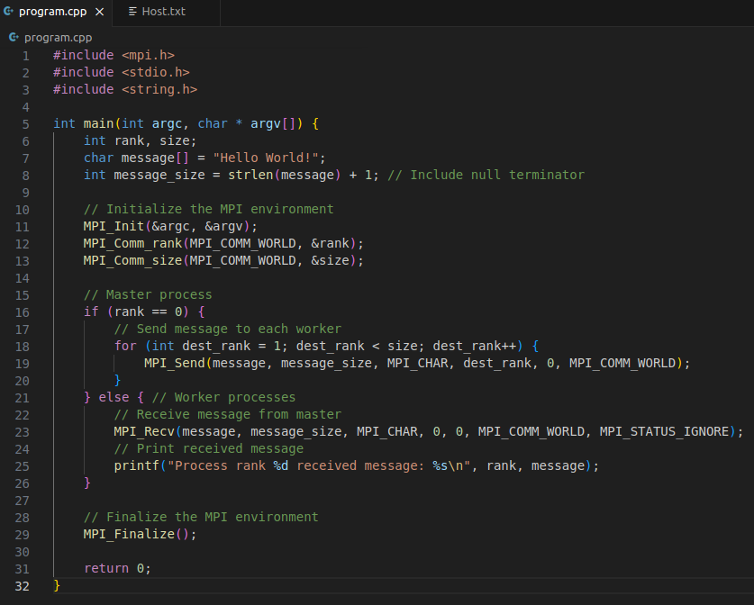

**Output of Code**

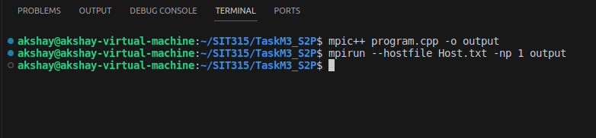

The below is the slave code

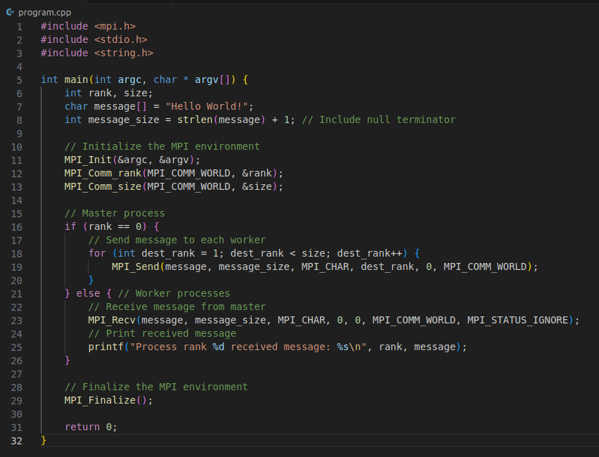

**Output of Code**

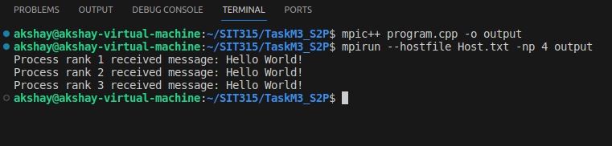

**Output of both the Codes**

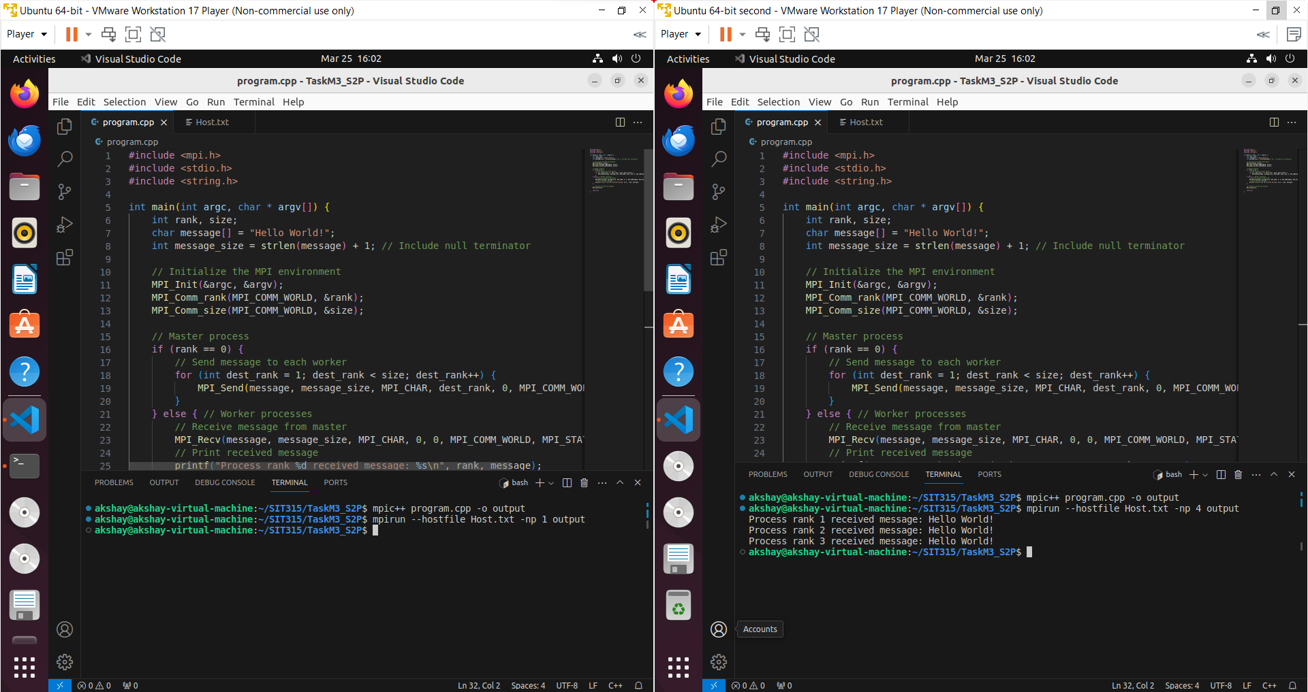

**Ans 2)**

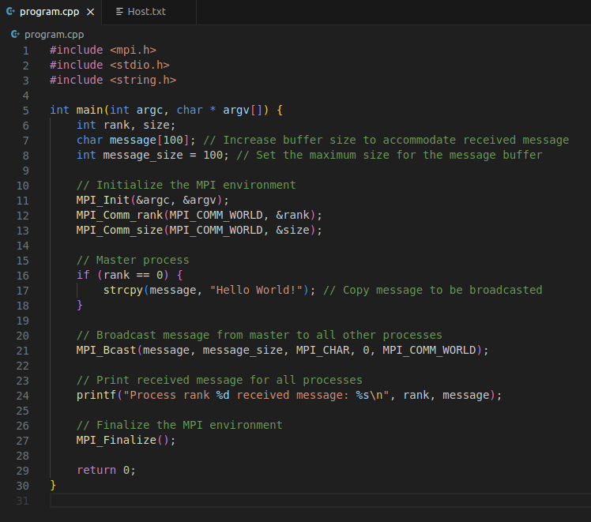

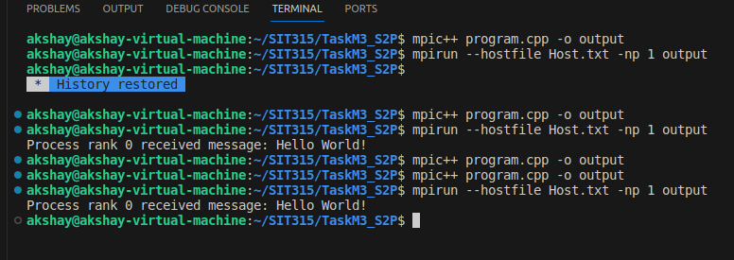

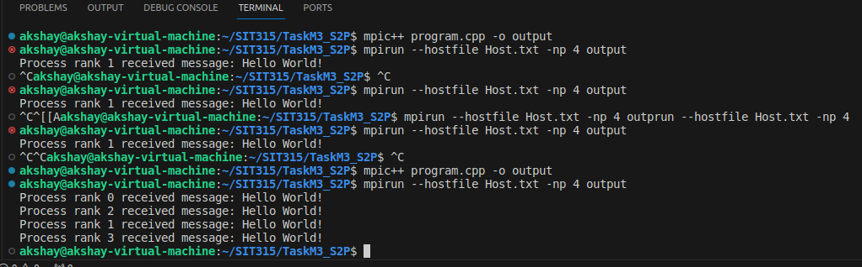

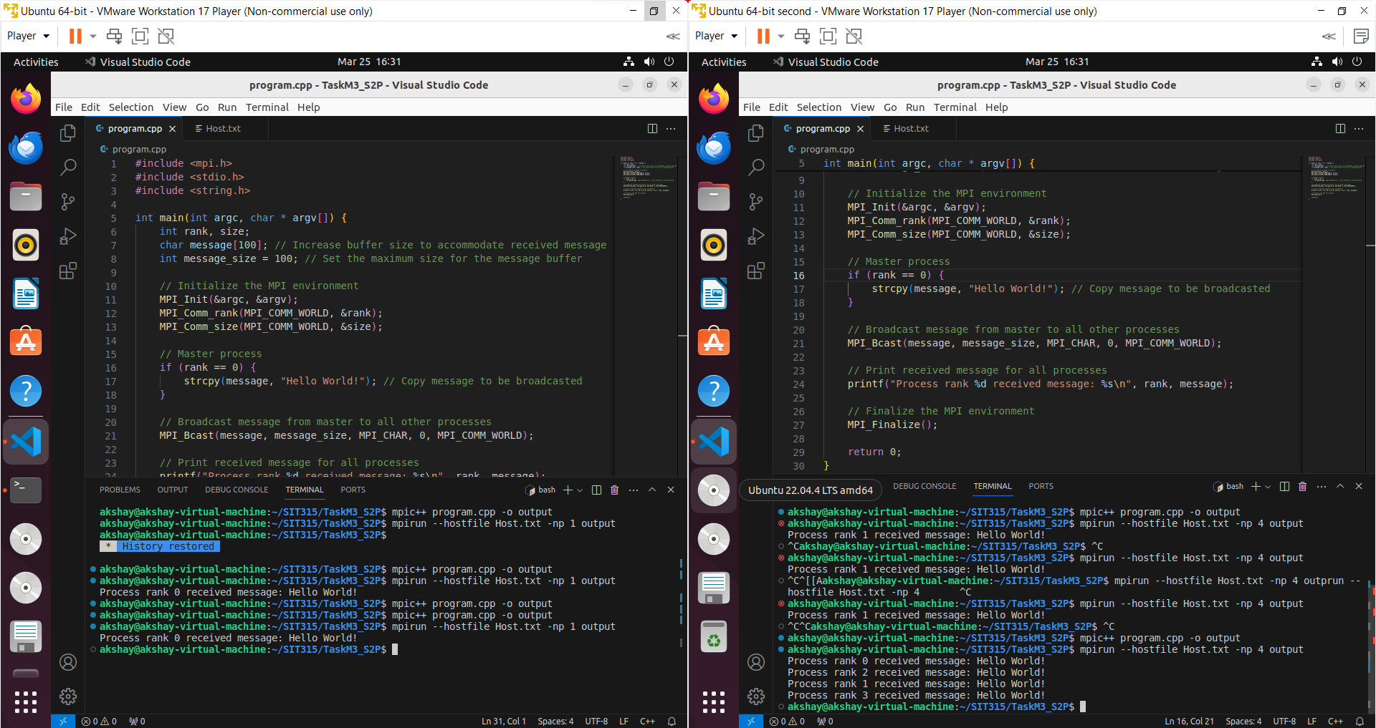

**Activity 2**

**Ans1)**

